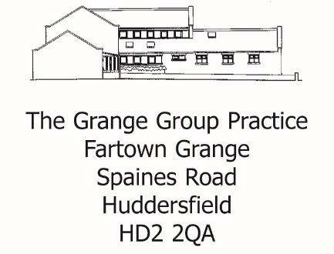
Tel: (01484) 428282
Grange.admin@nhs.net
Dr Rajkumar
Dr J Hawkswell

REQUEST FOR PRIVATE LETTER

Name: ____________________________ DOB:________________________
Address: ___________________________________________________________
Telephone no: ______________________ Mobile: ______________________

Date: ……………………………………….

What would you like the letter to address? Please give as much details as possible
To _________________________
___________________________________________________________________________
___________________________________________________________________________
___________________________________________________________________________
___________________________________________________________________________
___________________________________________________________________________
___________________________________________________________________________
___________________________________________________________________________
___________________________________________________________________________
___________________________________________________________________________
___________________________________________________________________________
A non-refundable fee of £20:00 is payable – Cash only
Please allow 28 days for this letter to be done.
Checked details above and the information is accurate.
Signed …………………………………………. Date: ………………………………………
Please hand this form to reception once complete. ___________________________________________________________________________
FOR PRACTICE USE ONLY
Date: _________________________ Staff Name: ………………………………
Amount Paid: ……………………………………….. Given to ……………………….............

